|  |  |  |
| --- | --- | --- |
|  | Web Admin CMS User Manual | |
| 8/22/2013 | Graduate Capstone |  |

Table of Contents

1 Introduction 4

1.1 Intended Audience 4

1.2 References 4

1.3 Revision History 4

2 Set Up 5

2.1 General Flow of the Web App 5

3 Main Menu 6

4 Code Administration 6

4.1 Code Type Manager 7

4.1.1 Add Code 8

4.1.2 Code Type List 8

4.2 Code Type Page 9

4.2.1 Add Code 9

4.2.2 Delete Code Type 10

4.2.3 Save Code Type Changes 10

4.2.4 Code Entry (Edit and Delete) 10

4.3 Code Page 10

4.3.1 Edit Code 11

4.3.2 Delete Code 11

4.3.3 Save Code Changes 11

5 Company and Survey Administration 12

5.1 Company Manager 13

5.1.1 Add Company 13

5.1.2 Company List 14

5.2 Company Page 14

5.2.1 Edit Company 15

5.2.2 Delete Company 15

5.2.3 Add Survey 15

5.2.4 Survey List 16

5.3 Survey Page 16

5.3.1 Edit Survey 17

5.3.2 Delete Survey 17

5.3.3. Add Revision 17

5.3.4 Revision List 18

5.4 Revision Page 18

5.4.1 Edit Revision 19

5.4.2 Delete Revision 19

5.4.3 Add Question 19

5.4.4 Question List 20

5.4.5 Link Questions 20

5.4.6 Perform Automated Test 21

5.5 Question Page 21

5.5.1 Edit Question 22

5.5.2 Delete Question 22

5.5.3 Add Form Element 22

5.5.4 List of Form Elements 23

5.5.5 Add Automation Element 23

5.5.6 List of Automation Elements 24

5.5.7 Delete All Form Flows 24

5.5.8 Delete All Automation Flows 24

5.6 Form Element Page 25

5.6.1 Edit Form Element 25

5.6.2 Delete Form Element 26

5.6.3 Add Form Element Option 26

5.6.4 List Form Element Options 26

5.6.5 Add Form Element Attribute 27

5.6.6 List Form Element Attribute 27

5.7 Form Element Option Page 28

5.7.1 Edit Form Element Option 28

5.7.2 Delete Form Element Option 29

5.8 Command Element Page 29

5.8.1 Edit Command Element 30

5.8.2 Delete Command Element 30

5.8.3 Add Command Element Identifier 31

5.8.4 List Command Element Identifier 31

5.8.5 Add Command Form Element Relation 32

5.8.6 List Command Form Element Relation 32

5.9 Command Element Identifier Page 33

5.9.1 Edit Command Element Identifier 33

5.9.2 Delete Command Element Identifier 34

7 Frequently Asked Questions 35

7.1 I made a change, but the webpage didn’t update? 35

7.2 Are there any credentials need to use the Admin Site 35

# 1 Introduction

The purpose of this document is to explain and give an in depth analysis on the structure, design and make up of Company Survey Websites. By doing so, this will give a great understanding to the complexity involved with having to re-create these surveys in the system.

## 1.1 Intended Audience

This document is intended for persons trying to understand the fundamental business side of how survey work for this project. The goal is for those individuals to learn about the surveys and learn what is involved to recreate the surveys in the system.

## 1.2 References

No references were used.

## 1.3 Revision History

Managing the change history of this document will occur in this table.

|  |  |  |  |
| --- | --- | --- | --- |
| Name | Date | Reason For Change | Version |
| Andy Bottom | 08/08/2013 | Created the introduction and parts of the document. | 0.1 |
| Andy Bottom | 08/22/2013 | Finished the rest of the manual. | 1.0 |

# 2 Set Up

The Web Admin requires a server running .Net 4.0 and up in order to run. The project can be supplied upon request.

## 2.1 General Flow of the Web App

Below is a diagram which shows the overall flow of the Web Admin CMS Application and the interaction between pages.

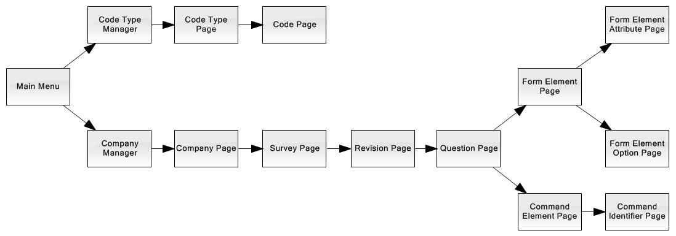

# 3 Main Menu

The main menu contains the links to the major sections of the application. All the administrator functionality can be linked to from this page.

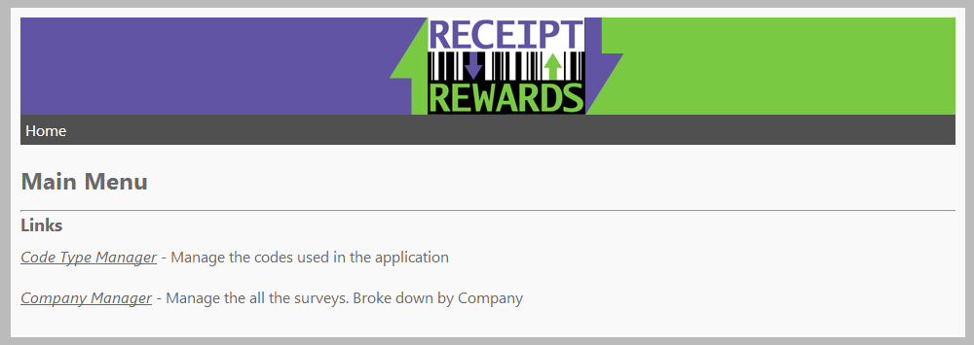

# 4 Code Administration

The Code Administration of the Application is used to manage all the codes and code types of the system. The codes are essentially constants of the system that are used and referenced in the code.

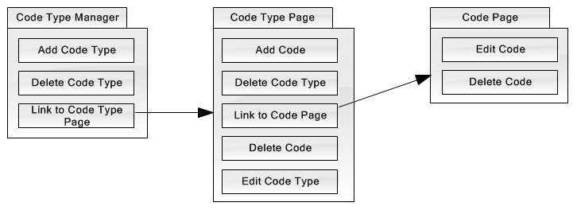

## 4.1 Code Type Manager

The Code Type Manager page is used to manage all the Code Types in the system. Code Types are essentially categories for the Codes. The Code Types have a certain purpose and part of the system for specialized functionality.

Code Types will be updated infrequently and almost always be updated by a developer. The reason is because when code types need to be updated, it almost always involves is due to a new development request that needs the new Code Type. Otherwise, most code types have no need to be updated once they are made. Also, it is very important to be diligent when deleting a code or code type because there may be references associated to those.

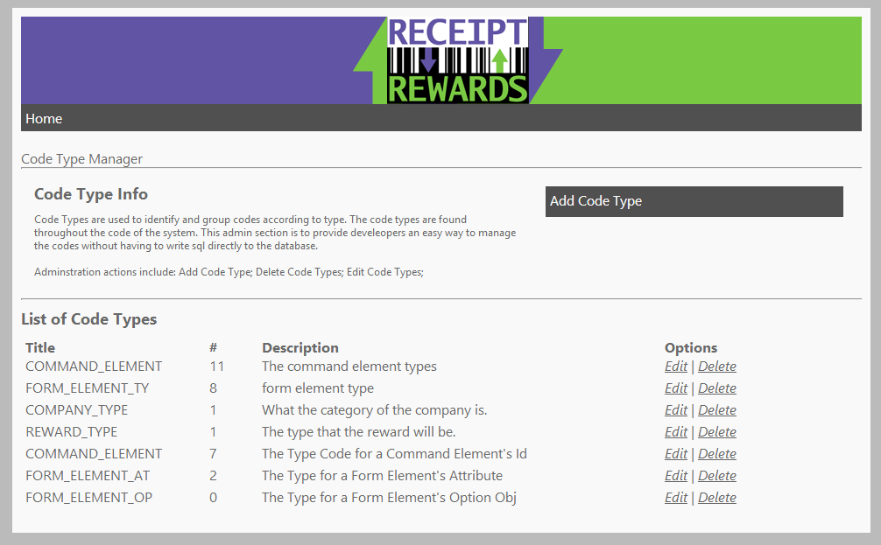

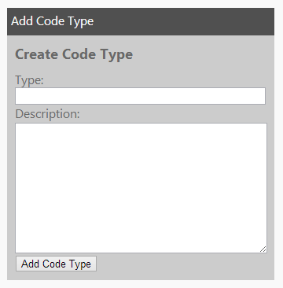

### 4.1.1 Add Code

* Use the Add Code Type form to add a new Code Type to the system.
* The Type field is a unique string to identify a single Code Type
* The description field is a string which types will be used in reference

### 4.1.2 Code Type List

On the Code Type Manager is a list of all the Code Types in the system. With this list you can perform a delete of the Code Type. Also, if you wish to edit the Code Type, click the “edit” link and that will take you to the Code Type Page.



## 4.2 Code Type Page

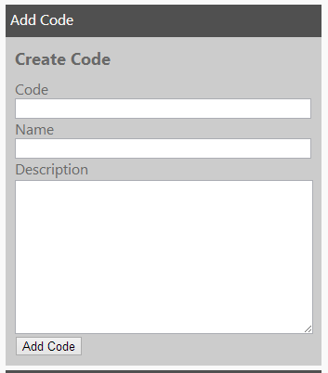The Code Type page is the page that allows you to manage all aspects of a code that is in the system. You can also manage Codes that are part of that Code Type.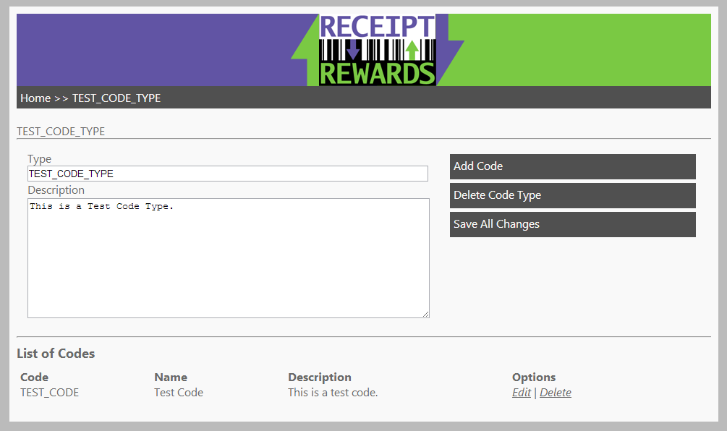

### 4.2.1 Add Code

Use the Add Code form to add a new Code to the current Code Type.

* The Code field is a unique identifying name.
* The name is the human readable version of the code.
* Description is a description to describe what purpose the Code has.

### 4.2.2 Delete Code Type

To delete a Code Type, click the “Delete Code Type” button.

### 4.2.3 Save Code Type Changes

To save changes to the Code Type, click the “Save All Changes” button.

### 4.2.4 Code Entry (Edit and Delete)

At the bottom of the page is a list of Codes. These codes are all the codes that are part of the current Code Type. There are links to delete or edit that code. The edit will link to the Code Page for that code.



## 4.3 Code Page

The Code Page is the page to manage a Code that is in the system.

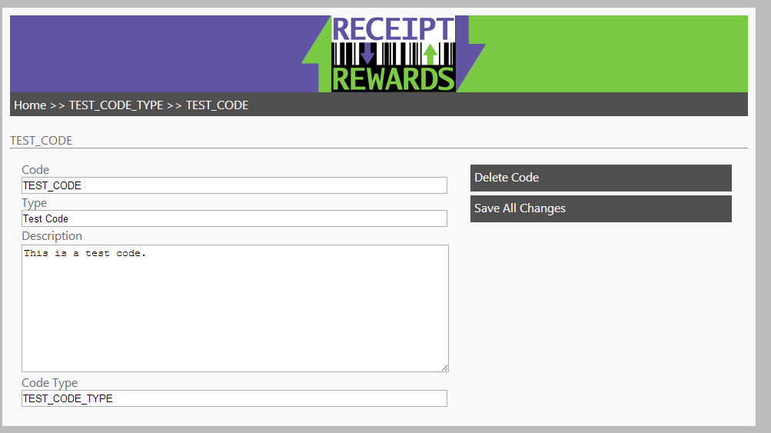

### 4.3.1 Edit Code

The Edit form allows the user to update properties of the current Code.

* Code field is a string that represents the code, which is a computer readable identifier
* The name field is a human readable name for the code.
* The Description field is a string that summarizes the purpose of that code and what it represents.

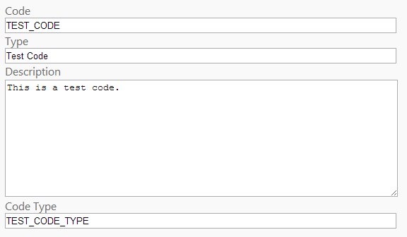

### 4.3.2 Delete Code

To delete the code, click the “Delete Code” button.

### 4.3.3 Save Code Changes

To save all the changed on the Edit Code form, then click the “Save All Changes” button

# 5 Company and Survey Administration

The following next module of the application involves managing all the surveys and company in the CMS. Below is a diagram showing the flow of the Company and Survey Administration Module with all the actions of each page.

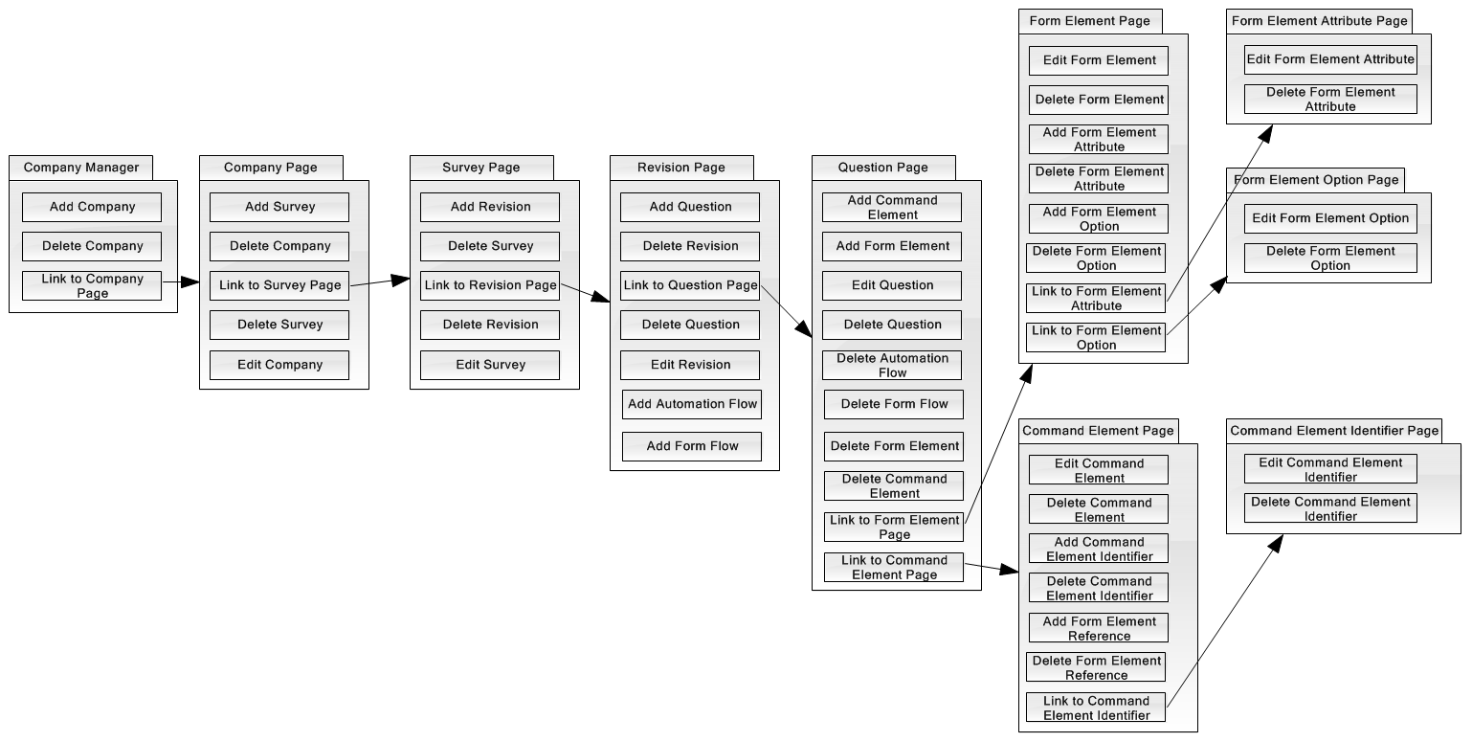

## 5.1 Company Manager

The company manager is a list that displays all the companies in the system. This is the starting point to drill down into the companies.

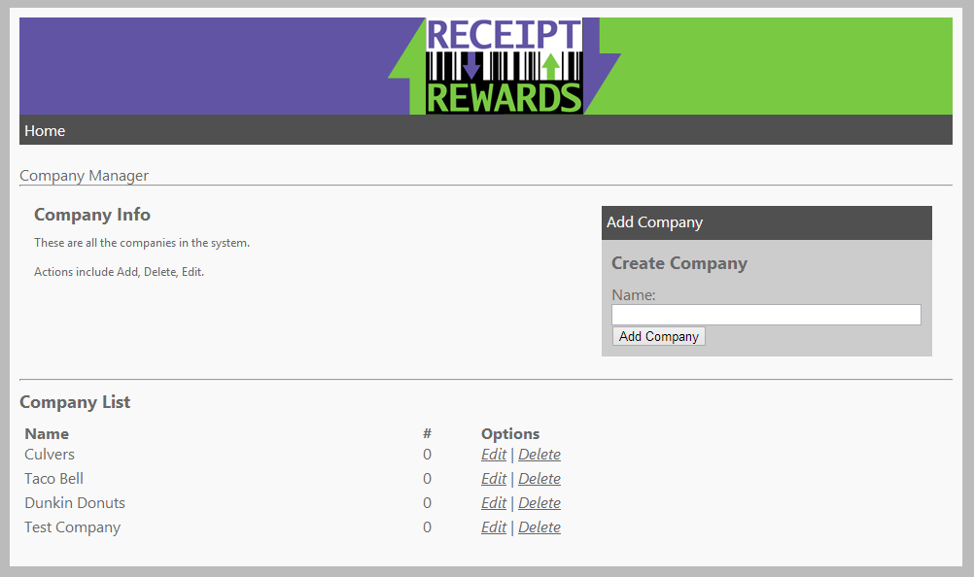

### 5.1.1 Add Company

To add a new company to the system use the add company form. The “Name” field requests a string which would be the name of the Company. Then click the “Add Company” button to add the company to the system.

### 5.1.2 Company List

On the Company Manager Page, you will find that there is a list which shows all the companies in the system. With this list, you can delete the company by clicking the “Delete” link. To edit the company, click the “Edit” link and that will direct you to the Company Page.

## 5.2 Company Page

The Company Page is used to manage all the properties for any given Company object that is in the system. A Company is a representation of the actual Company of which the desired survey is actually a part of.

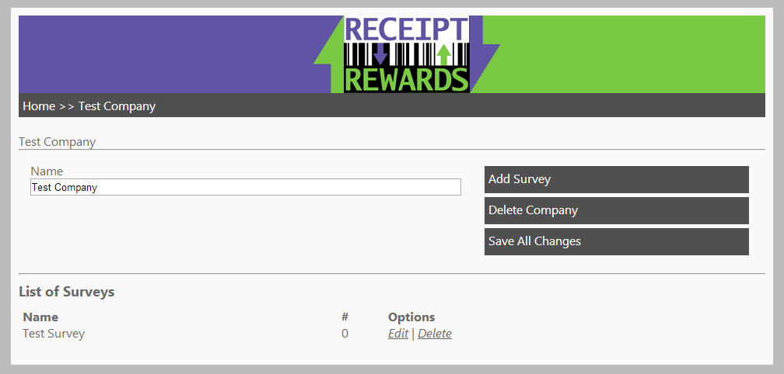

### 5.2.1 Edit Company

To edit attributes about the Company, use the Edit Company Form. This form contains the Name of the Company which should be a string. Once you have entered in all the desired information, click the “Save All Changes” button to save your changes.

### 5.2.2 Delete Company

To delete the current company from the system, click the “Delete Company” button. This will delete the company and redirect you back to the Company Manager Page. Remember, this action cannot be undone, and all the information associated to company will also be removed.

### 5.2.3 Add Survey

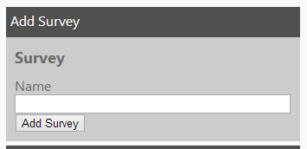To create a new survey for the company, use the “Add Survey” form. In this form, input a string value into the “Name” field, which would represent a meaningful name to that survey. Once the fields have been entered, click the “Add Survey” button and this will create the survey. You can now find the newly created Survey in the Survey List.

### 5.2.4 Survey List

To view a list of all the Surveys that are associated to the Company, look at the Survey List. In this list you can perform the following actions to the Survey. To delete the Survey, click the “Delete” link, which will remove the Survey and all related objects of the Survey in the system. If you want to make changes to the Survey, click the “Edit” link and you will be redirected to the Survey Page.



## 5.3 Survey Page

The Survey Page is a representation of a Survey Object in the database. The Surrey is a representation of an actual Survey that will be created for users to fill out.

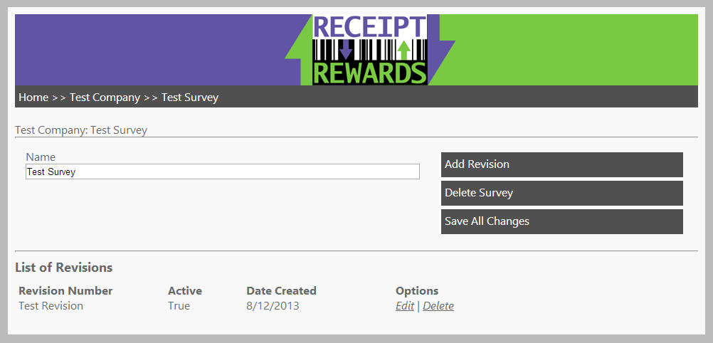

### 5.3.1 Edit Survey

To change information of the current survey, use the “Edit Survey” form. This form contains a Name field which is a string of a meaningful name for the survey. Once all the fields have been entered, click the “Save All Changes” button. The page will refresh and you can see the new changes.



### 5.3.2 Delete Survey

To delete the current Survey from the system, click the “Delete Survey” button. This will delete the survey and redirect you back to the parent Company Page. Remember, this action cannot be undone, and all the information associated to survey will also be removed.



### 5.3.3. Add Revision

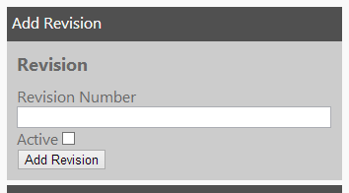To create a new Revision for the Survey, use the “Add Revision” form. In this form, input a string value into the “Revision Number” field, which would represent a meaningful name for what version of the revision it is. The “Active” checkbox sets whether it will be the active Revision of the Survey. Once all the fields have been entered, click the “Add Revision” button and this will create the Revision into the system. You can now find the newly created Revision in the Revision List. Note that if the new Revision gets marked as the active one, then the other Revision of the Survey will be set to inactive.

### 5.3.4 Revision List

On the Survey Page, you will find that there is a list which shows all the Revisions associated to the Survey. With this list, you can delete a Revision by clicking the “Delete” link. To edit the Revision, click the “Edit” link and that will direct you to the Revision Page.



## 5.4 Revision Page

The Revision Page is a representation of a Revision Object in the database. The Revision is a realization of an individual version of a Survey.

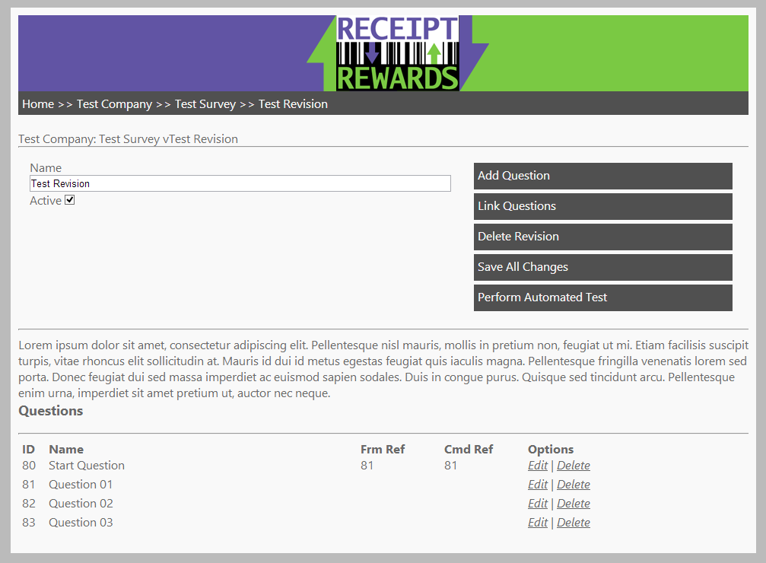

### 5.4.1 Edit Revision

To change information of the current Revision, use the “Edit Revision” form. This form contains the “Name” field which should be a string containing meaningful version name of the Revision. The “Active” field is a checkbox to determine if the current Revision is the active on for the Survey. Once all the fields have been entered, click the “Save All Changes” button. The page will refresh and you can see the new changes. Note that if you set the Revision to active, the other Revision will be set to inactive as only one Revision can be active per Survey.

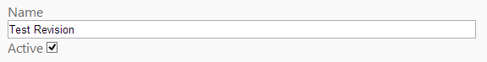

### 5.4.2 Delete Revision

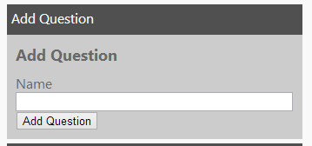To delete the current Revision from the system, click the “Delete Revision” button. This will delete the revision and redirect you back to the parent Survey Page. Remember, this action cannot be undone, and all the information associated to survey will also be removed. Also note, that very rarely, revisions should never be deleted if the Revision has been in use by users because this will delete all the references. Instead, it is advised to simply create a new revision and set that one as active. This way, this survey will be inactive, but still in the database to preserve the data.

### 5.4.3 Add Question

To create a new Question for the revision, use the “Add Question” form. In this form, input a string value into the “Name” field, which would represent a meaningful name to the question. Once all the fields have been entered, click the “Add Question” button and this will create the Question into the system. You can now find the newly created Question in the Question List.

### 5.4.4 Question List

On the Revision Page, there is a list of all the Questions associated to the current Revision. The columns show properties of the Question. The ID column is the Question ID. The name column is the meaningful name of the Question. The Frm Ref is shows the ids of the next Questions in the Form flow. The Cmd Ref shows the next ids of Questions for the Automation flow. In the Options column, you can delete a Question by clicking the “Delete” link. To edit the Question, click the “Edit” link and that will direct you to the Question Page. 

### 5.4.5 Link Questions

The “Link Questions” form is used to add new flows to a Question. There are two types of Flows, Form and Automation. The flow is essentially a reference for where the question could possibly go to next.

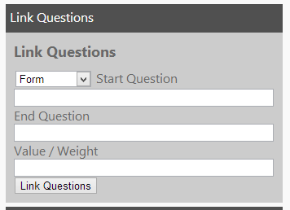To create a new Flow for a Question, use the “Link Questions” form. Select either Form or Automation in the dropdown box for what flow the reference should be added to. The “Start Question” field requires an integer of the ID of the Question which the reference will be added to. The “End Question” field requires an integer of the ID of the Question which is the target of the reference. The “Value / Weight” field varies on the flow. In the Form Flow, the field requires a string for the value that the flow will take if found, (the default flow is left blank.) In the Automation Flow, the field requires an integer to identify the prioritization weight of the flow. The default flow should have the largest value, which will execute last. Once all the fields have been entered, click the “Link Questions” button and this will create the Flow reference into the system. You can now see the added flow reference under the Question in either the Frm Flow or Cmd Flow columns of the Question List.

### 5.4.6 Perform Automated Test

To test whether or not the revision still works, you can manually perform an automated test, but clicking the “Perform Automated test” button. If the test succeeds, then a success message will display saying the test was a success. Otherwise an error message will be returned. If an error message does occur, then a more thorough look is needed by the admin. Remember, a success means that the survey is up-to-date, but a failure doesn’t necessarily mean that the revision is out of date, but does require a further analysis.

## 5.5 Question Page

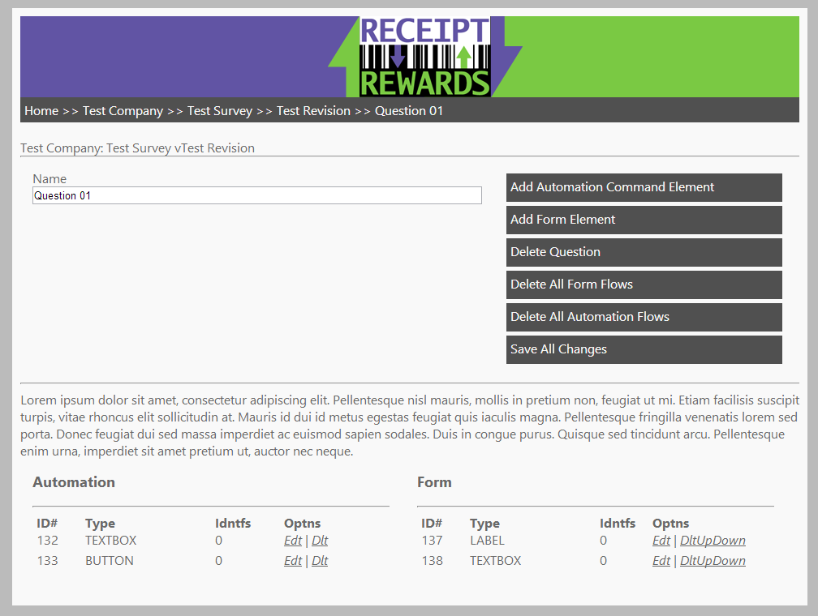The Revision Page is the management of Question object in the database. The Question is a representation of a single question or section of the satisfaction survey.

### 5.5.1 Edit Question

To change information of the current Question, use the “Edit Question” form. This form contains the “Name” field which should be a string containing meaningful name of the Question. Once all the fields have been entered, click the “Save All Changes” button. The page will refresh and you can see the new changes.



### 5.5.2 Delete Question

To delete the current Question from the system, click the “Delete Question” button. This will delete the question and redirect you back to the parent Revision Page. Remember, this action cannot be undone, and all the information associated to question will also be removed.

### 5.5.3 Add Form Element

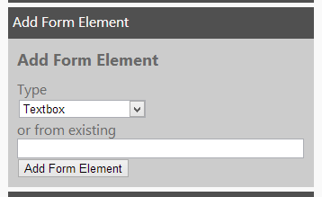To create a new Form Element for the Question, use the “Add Form Element” form. In this form, select the desired “Type” from the drop down box which would represent what type of form element it is, (the options are created from the Codes in the FORM_ELEMENT_TYPE code type.) Another option is to input an integer of an existing Form Element’s id. This will create a new reference to the current question, (and not create a new Form Element.) Otherwise, once all the desired fields have been entered, click the “Add Form Element” button and this will create the Form Element into the system. You can now find the newly created or associated Form Element in the Form Element List.

### 5.5.4 List of Form Elements

On the Question Page, there is a list of all the Form Elements associated to the current Question and Form. The columns display several attributes. The ID column is the Form Element Id. The type column is the Type of the Form Element. In the Options column, you can delete a Command Element by clicking the “Delete” link. To edit the Form Element, click the “Edit” link and that will direct you to the Form Element Page.

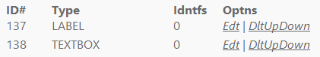

### 5.5.5 Add Automation Element

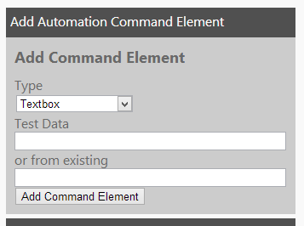To create a new Automation Element for the Question, use the “Add Command Element” form. In this form, select the desired “Type” from the drop down box which would represent what type of Command Element it is, (the options are created from the Codes in the COMMAND_ELEMENT_TYPE code type.) Another option is to input an integer of an existing Command Element’s id. This will create a new reference to the current question, (and not create a new Command Element.) Otherwise, once all the desired fields have been entered, click the “Add Command Element” button and this will create the Command Element into the system. You can now find the newly created or associated Command Element in the Command Element List.

### 5.5.6 List of Automation Elements

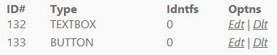On the Question Page, there is a list of all the Command Elements associated to the current Question and Automation. The columns display several attributes. The ID column is the Command Element Id. The type column is the type of the Command Element. In the Options column, you can delete a Command Element by clicking the “Delete” link. To edit the Command Element, click the “Edit” link and that will direct you to the Command Element Page.

### 5.5.7 Delete All Form Flows

To delete the all Form Flows related to the current Question, click the “Delete All Form Flows” button. This will delete the associated Form Flows. Remember, this action cannot be undone, and all the references that the Form Flows created will be removed.

### 5.5.8 Delete All Automation Flows

To delete the all Automation Flows related to the current Question, click the “Delete All Automation Flows” button. This will delete the associated Automation Flows. Remember, this action cannot be undone, and all the references that the Automation Flows created will be removed.

## 5.6 Form Element Page

The Form Element Page is the management of Form Element object in the database. The Form Element is a representation of a single element (textbox, checkbox, etc…) in the satisfaction survey.

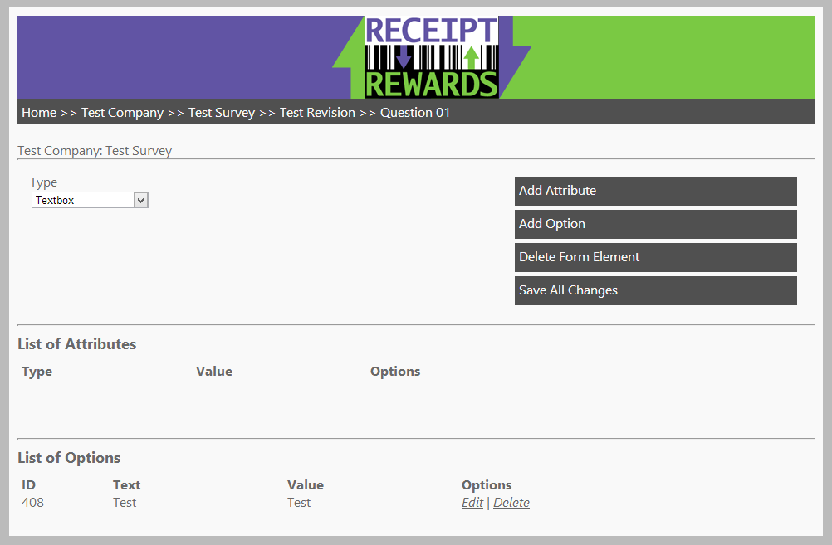

### 5.6.1 Edit Form Element

To change information of the current Form Element, use the “Edit Form Element” form. This form contains the “Type” field which is a dropdown box. Choose the option for what type the Form Element should be displayed as. Once all the fields have been entered, click the “Save All Changes” button. The page will refresh and you can see the new changes.

### 5.6.2 Delete Form Element

To delete the current Form Element from the system, click the “Delete Form Element” button. This will delete the form element and redirect you back to the parent Question Page. Remember, this action cannot be undone, and all the information associated to form element will also be removed.

### 5.6.3 Add Form Element Option

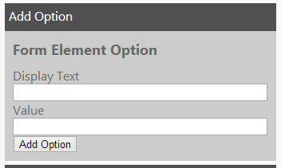To create a new Form Element Option for the Form Element, use the “Add Option” form. In this form, input a string value into the “Display Text” field, which would represent what the text of the option will be displayed to the user. The “Value” field is a string of the hidden value of the field that will be placed in the Submission Answer when the user submits the Form. Once all the fields have been entered, click the “Add Option” button and this will create the Form Element Option into the system. You can now find the newly created Form Element Option in the Form Element Option List.

### 5.6.4 List Form Element Options

On the Form Element Page, there is a list of all the Form Element Options associated to the current Form Element. The columns display several attributes. The ID column is the Form Element Option Id. The text column is the Display Text of the Form Element Option. The value column shows the hidden value of the Form Element Option. In the Options column, you can delete a Form Element Option by clicking the “Delete” link. To edit the Form Element Option, click the “Edit” link and that will direct you to the Form Element Option Page.



### 5.6.5 Add Form Element Attribute

To create a new Form Element Option for the Form Element, use the “Add Option” form. In this form, select an option in the “Attribute Type” field which indicated which attribute property will be added to the Form Element.. The “Value” field is a string of what the value for the new attribute should be. Once all the fields have been entered, click the “Add Attribute” button and this will create the Form Element Attribute into the system. You can now find the newly created Form Element Attribute in the Form Element Attribute List.

### 5.6.6 List Form Element Attribute

On the Form Element Page, there is a list of all the Form Element Attributes associated to the current Form Element. The columns display several attributes. The ID column is the Form Element Attribute Id. The type column is the Form Element Attribute’s type. The value column is the value of the Form Element Attribute. In the Options column, you can delete a Form Element Attribute by clicking the “Delete” link. To edit the Form Element Attribute, click the “Edit” link and that will direct you to the Form Element Attribute Page.

## 5.7 Form Element Option Page

The Form Element Option Page is the management of a single Form Element Option object in the database. The Form Element Option is a representation of a single option of a dropdown box, radio button, or checkbox in the satisfaction survey.

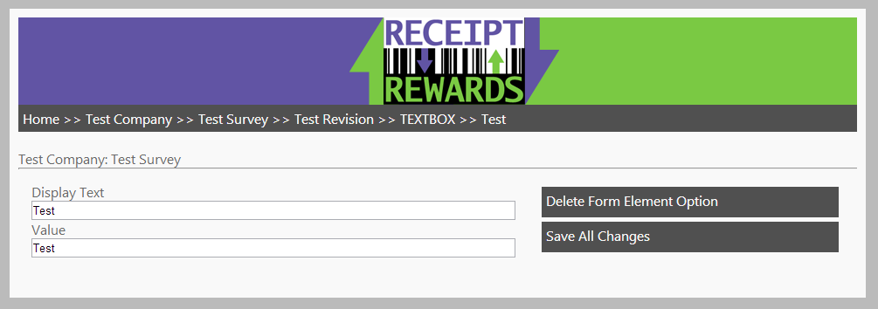

### 5.7.1 Edit Form Element Option

To change information of the current Form Element Option, use the “Edit Form Element Option” form. This form contains the “Display Text” field which should be a string of what the text should display as. The “Value” should be a string for what the hidden value will be stored. Once all the fields have been entered, click the “Save All Changes” button. The page will refresh and you can see the new changes.

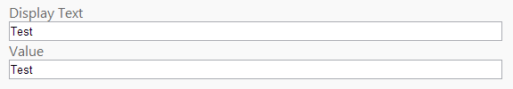

### 5.7.2 Delete Form Element Option

To delete the current Form Element Option from the system, click the “Delete Form Element Option” button. This will delete the form element and redirect you back to the parent Form Element Page. Remember, this action cannot be undone, and all the information associated to form element option will also be removed.

## 5.8 Command Element Page

The Command Element Page is the management of a single Command Element object in the database. The Command Element is a representation of the single action involved with filling out the satisfaction survey.

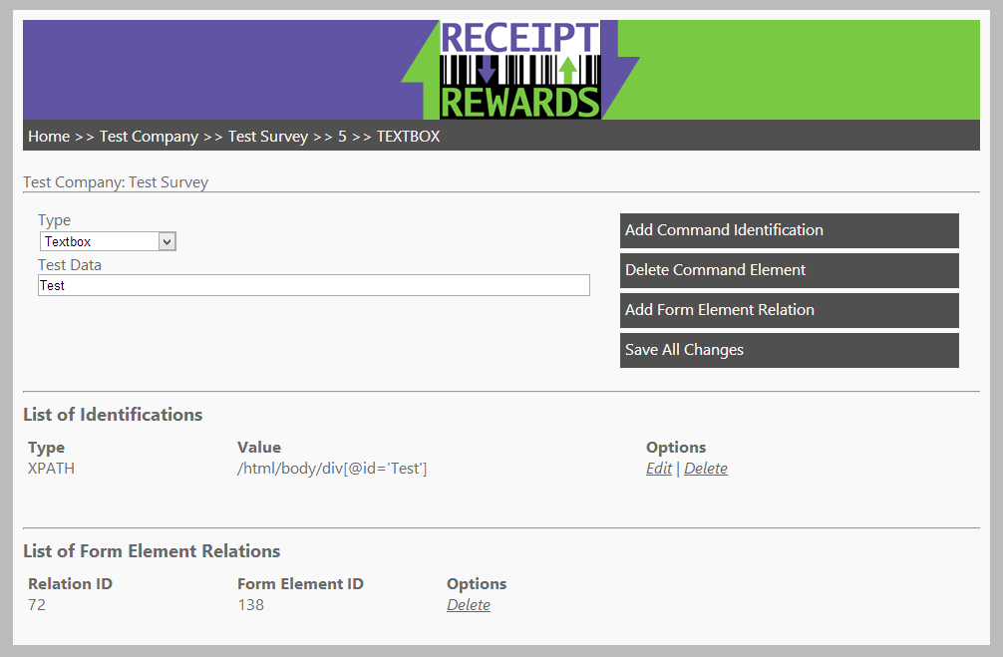

### 5.8.1 Edit Command Element

To change information of the current Command Element, use the “Edit Command Element” form. This form contains the “Type” field which is a dropdown box. Choose the option for what type the Form Element should be displayed as. The “Test Data” should be a string of what the Web Driver will use for the test automation. Once all the fields have been entered, click the “Save All Changes” button. The page will refresh and you can see the new changes.

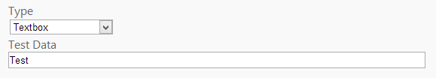

### 5.8.2 Delete Command Element

To delete the current Command Element from the system, click the “Delete Command Element” button. This will delete the command element and redirect you back to the parent Question Page. Remember, this action cannot be undone, and all the information associated to command element will also be removed.

### 5.8.3 Add Command Element Identifier

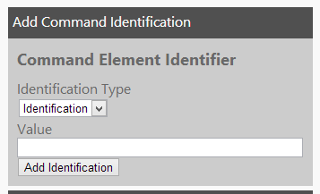To create a new Command Element Identifier for the Command Element, use the “Add Identification” form. In this form, select an option in the “Identification Type” field which indicates what the Command Element will be identified by the Web Driver. The “Value” field is a string of what the value for the new identifier is and will be looked for by the Web Driver. Once all the fields have been entered, click the “Add Identification” button and this will create the Command Element Identifier into the system. You can now find the newly created Command Element Identifier in the Command Element Identifier List.

### 5.8.4 List Command Element Identifier

On the Command Element Page, there is a list of all the Command Element Identifier associated to the current Command Element. The columns display several attributes. The ID column is the Command Element Identifier Id. The type column is the Command Element Identifier’s type. The value column is the value of the Command Element Identifier. In the options column, you can delete a Command Element Identifier by clicking the “Delete” link. To edit the Command Element Identifier, click the “Edit” link and that will direct you to the Command Element Identifier Page.

### 5.8.5 Add Command Form Element Relation

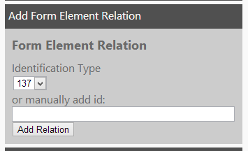To create a new Form Element Relation for the Command Element, use the “Add Form Element Relation” form. In this form, you may select an option in the “Identification Type” field which contains the Form Element Ids of the current Question. Otherwise, you may input an integer into the “Manually Add ID” field of another element that isn’t in the current form. Once one of the options has been entered, click the “Add Relation” button and this will create the Form Element Relation to the Command Element into the system. You can now find the newly created Form Element Relation in the Form Element Relation List.

### 5.8.6 List Command Form Element Relation

On the Command Element Page, there is a list of all the Form Element Relations associated to the current Command Element. The columns display several attributes. The ID column is the Form Element Relation Id. The form element id column is the Form Element Id that is being referenced. In the options column, you can delete a Form Element Relation by clicking the “Delete” link.



## 5.9 Command Element Identifier Page

The Command Element Identifier Page is the management of a single Command Element Identifier object in the database. The Command Element Identifier is a representation of the ID, Class, or Name of an HTML Element in the satisfaction survey.

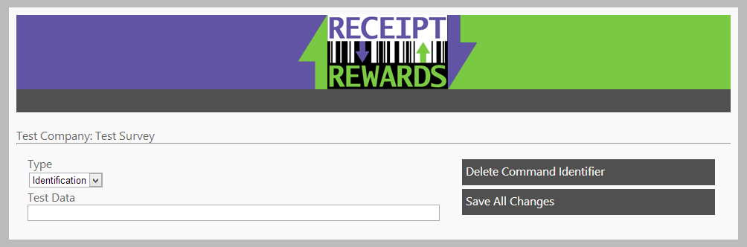

### 5.9.1 Edit Command Element Identifier

To change information of the current Command Element Identifier, use the “Edit Command Element Identifier” form. This form contains the “Type” field which is a dropdown box. Choose the option represents how the Web Driver will identify the Web Element. The “Test Data” field is a string for what the Web Driver will use during the Automation Test. Once all the fields have been entered, click the “Save All Changes” button. The page will refresh and you can see the new changes.

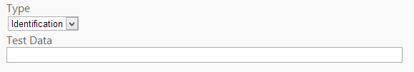

### 5.9.2 Delete Command Element Identifier

To delete the current Command Element Identifier from the system, click the “Delete Command Element Identifier” button. This will delete the command element identifier and redirect you back to the parent Command Element Page. Remember, this action cannot be undone, and all the information associated to command element identifier will also be removed.

# 7 Frequently Asked Questions

## 7.1 I made a change, but the webpage didn’t update?

Sometimes after performing an insert, update or delete, the screen doesn’t refresh the content and just displays what was cached.

If this happens, simply perform click on the breadcrumb navigation of the current page, and it will perform a hard refresh of the content. Your changes should now be displayed correctly.

## 7.2 Are there any credentials need to use the Admin Site

Currently there are no credentials because the website is only hosted on local computers of the Administrators computers. However, if in the future the administrator site is put up on a public server, then yes, credentials will need to be added for security of the data.